**UNIX I/O**

**LAB # 05**



**Fall 2022**

**CSE302L System Programming Lab**

Submitted by: Maaz Habib

Registration No.: **20PWCSE1952**

Class Section: **C**

“On my honor, as student of University of Engineering and Technology, I have neither given nor received unauthorized assistance on this academic work.” Student Signature: ______________

Submitted to:

**Engr. Abdullah Hamid**

November 14, 2022,

**Department of Computer Systems Engineering**

**University of Engineering and Technology, Peshawar**

**Lab Objective(s):**

• Understand and implement read, write, open, close and unlink function calls.

**Task # 01:**

**Implement the cp command. Code:**

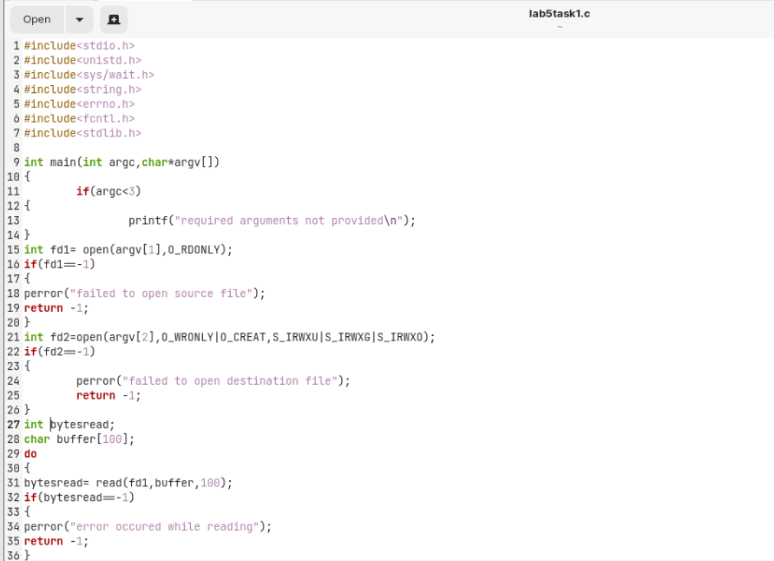

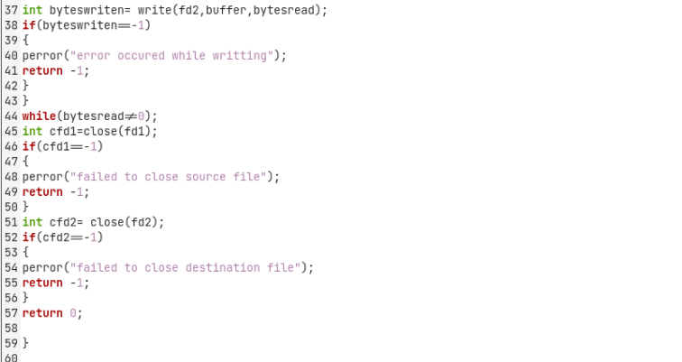

**Output/Results:**

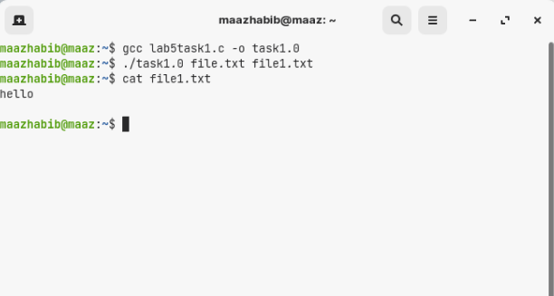

**Task # 02:**

**Implement rm command.**

**Code:**

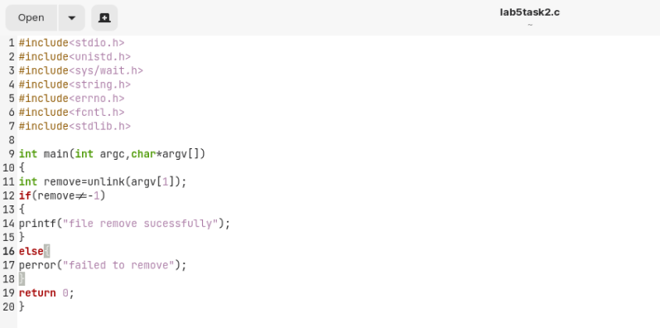

**Output:**

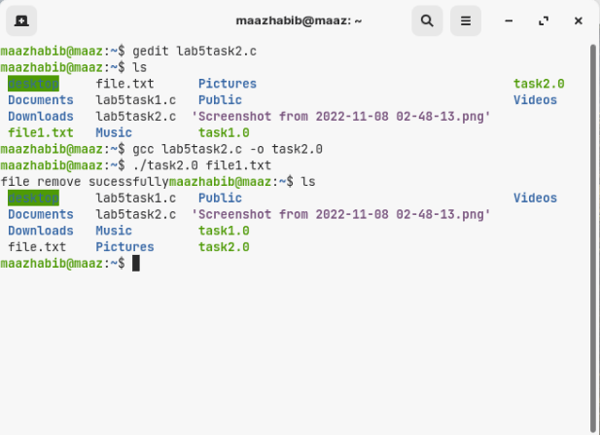

**Task 3:**

**Implement the mv command.**

**Code:**

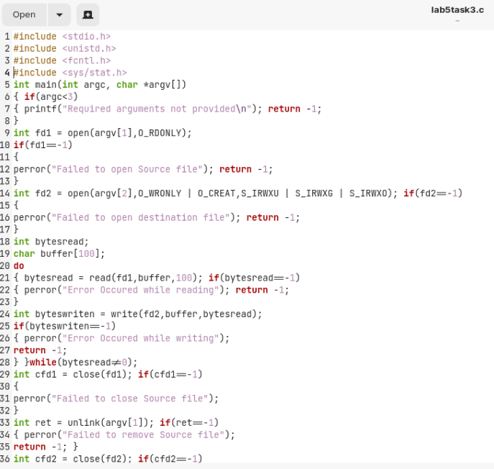

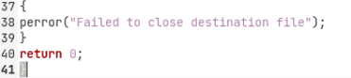

**Output:**

